**Exercise 1: Configuring a Basic Spring Application**

**BookRepository.java**

package com.library.repository;

public class BookRepository {

public void display() {

System.out.println("BookRepository: displaying book info");

}

}

**BookService.java**

package com.library.service;

import com.library.repository.BookRepository;

public class BookService {

private BookRepository bookRepository;

public void setBookRepository(BookRepository bookRepository) {

this.bookRepository = bookRepository;

}

public void serve() {

System.out.println("BookService: serving request...");

bookRepository.display();

}

}

**applicationContext.xml**

<?xml version="1.0" encoding="UTF-8"?>

<beans xmlns="http://www.springframework.org/schema/beans"

xmlns:xsi="http://www.w3.org/2001/XMLSchema-instance"

xsi:schemaLocation="

http://www.springframework.org/schema/beans

http://www.springframework.org/schema/beans/spring-beans.xsd">

<bean id="bookRepository" class="com.library.repository.BookRepository"/>

<bean id="bookService" class="com.library.service.BookService">

<property name="bookRepository" ref="bookRepository"/>

</bean>

</beans>

**MainApp.java**

package com.library;

import com.library.service.BookService;

import org.springframework.context.ApplicationContext;

import org.springframework.context.support.ClassPathXmlApplicationContext;

public class MainApp {

public static void main(String[] args) {

ApplicationContext context = new ClassPathXmlApplicationContext("applicationContext.xml");

BookService service = context.getBean("bookService", BookService.class);

service.serve();

}

}

**Output:**

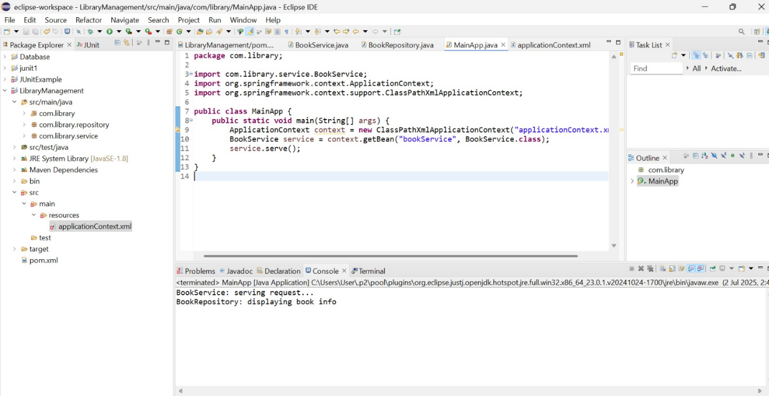

**Exercise 2: Implementing Dependency Injection**

**applicationContext.xml**

<?xml version="1.0" encoding="UTF-8"?>

<beans xmlns="http://www.springframework.org/schema/beans"

xmlns:xsi="http://www.w3.org/2001/XMLSchema-instance"

xsi:schemaLocation="

http://www.springframework.org/schema/beans

http://www.springframework.org/schema/beans/spring-beans.xsd">

<bean id="bookRepository" class="com.library.repository.BookRepository" />

<bean id="bookService" class="com.library.service.BookService">

<property name="bookRepository" ref="bookRepository" />

</bean>

</beans>

**Output:**

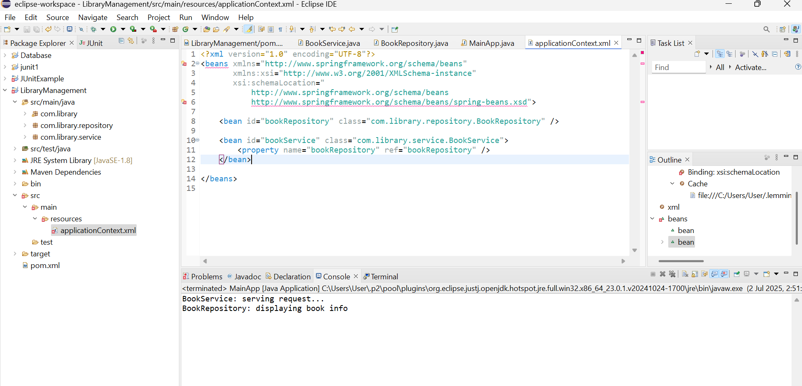

**Exercise 4: Creating and Configuring a Maven Project**

**Pom.xml**

<project xmlns="http://maven.apache.org/POM/4.0.0"

xmlns:xsi="http://www.w3.org/2001/XMLSchema-instance"

xsi:schemaLocation="http://maven.apache.org/POM/4.0.0

http://maven.apache.org/xsd/maven-4.0.0.xsd">

<modelVersion>4.0.0</modelVersion>

<groupId>com.library</groupId>

<artifactId>LibraryManagement</artifactId>

<version>1.0-SNAPSHOT</version>

<packaging>jar</packaging>

<name>LibraryManagement</name>

<url>http://maven.apache.org</url>

<dependencies>

<!-- Spring Core -->

<dependency>

<groupId>org.springframework</groupId>

<artifactId>spring-context</artifactId>

<version>5.3.32</version>

</dependency>

<!-- Spring AOP -->

<dependency>

<groupId>org.springframework</groupId>

<artifactId>spring-aop</artifactId>

<version>5.3.32</version>

</dependency>

<!-- Spring WebMVC -->

<dependency>

<groupId>org.springframework</groupId>

<artifactId>spring-webmvc</artifactId>

<version>5.3.32</version>

</dependency>

<!-- JUnit for testing -->

<dependency>

<groupId>junit</groupId>

<artifactId>junit</artifactId>

<version>3.8.1</version>

<scope>test</scope>

</dependency>

</dependencies>

<build>

<plugins>

<!-- Maven Exec Plugin to run Main class -->

<plugin>

<groupId>org.codehaus.mojo</groupId>

<artifactId>exec-maven-plugin</artifactId>

<version>3.1.0</version>

<configuration>

<mainClass>com.library.MainApp</mainClass>

</configuration>

</plugin>

<!-- Maven Compiler Plugin to set Java version -->

<plugin>

<groupId>org.apache.maven.plugins</groupId>

<artifactId>maven-compiler-plugin</artifactId>

<version>3.8.1</version>

<configuration>

<source>1.8</source>

<target>1.8</target>

</configuration>

</plugin>

</plugins>

</build>

</project>

**Output:**

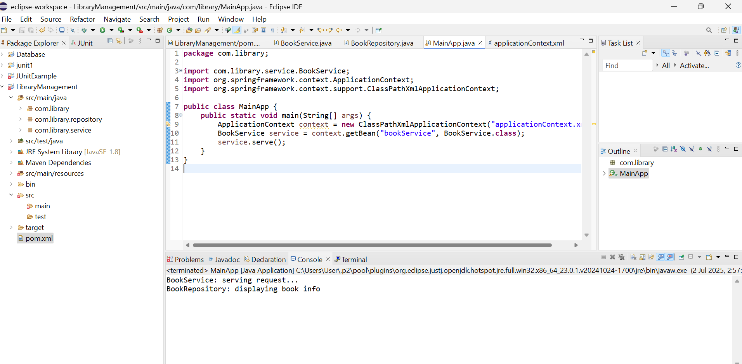

**Exercise 5: Configuring the Spring IoC Container**

**applicationContext.xml**

<?xml version="1.0" encoding="UTF-8"?>

<beans xmlns="http://www.springframework.org/schema/beans"

xmlns:xsi="http://www.w3.org/2001/XMLSchema-instance"

xsi:schemaLocation="

http://www.springframework.org/schema/beans

http://www.springframework.org/schema/beans/spring-beans.xsd">

<bean id="bookRepository" class="com.library.repository.BookRepository"/>

<bean id="bookService" class="com.library.service.BookService">

<property name="bookRepository" ref="bookRepository"/>

</bean>

</beans>

**Output:**



**Exercise 7: Implementing Constructor and Setter Injection**

**BookService.java**

package com.library.service;

import com.library.repository.BookRepository;

public class BookService {

private BookRepository bookRepository;

// ✅ Constructor Injection

public BookService(BookRepository bookRepository) {

System.out.println("BookService: Constructor Injection used");

this.bookRepository = bookRepository;

}

// ✅ Setter Injection (still supported)

public void setBookRepository(BookRepository bookRepository) {

System.out.println("BookService: Setter Injection used");

this.bookRepository = bookRepository;

}

public void serve() {

System.out.println("BookService: serving request...");

bookRepository.display();

}

}

**applicationContext.xml**

<beans xmlns="http://www.springframework.org/schema/beans"

xmlns:xsi="http://www.w3.org/2001/XMLSchema-instance"

xsi:schemaLocation="

http://www.springframework.org/schema/beans

http://www.springframework.org/schema/beans/spring-beans.xsd">

<!-- Define Repository Bean -->

<bean id="bookRepository" class="com.library.repository.BookRepository"/>

<!-- Constructor Injection for BookService -->

<bean id="bookService" class="com.library.service.BookService">

<constructor-arg ref="bookRepository"/>

<!-- Optional: add setter as well if needed -->

<!-- <property name="bookRepository" ref="bookRepository"/> -->

</bean>

</beans>

**Output:**

